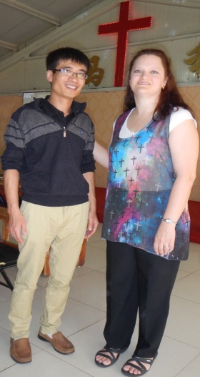
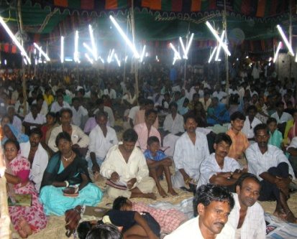

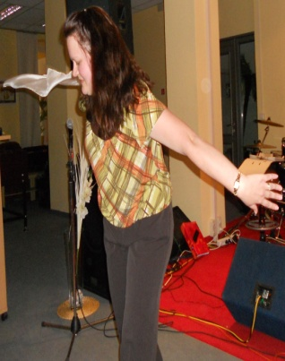
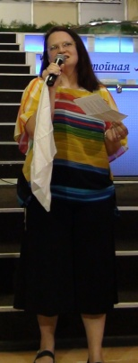
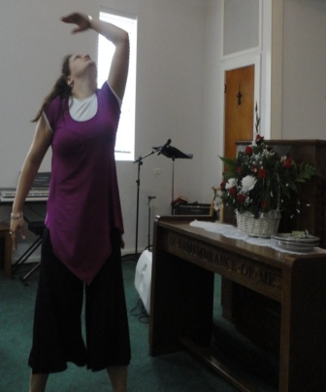
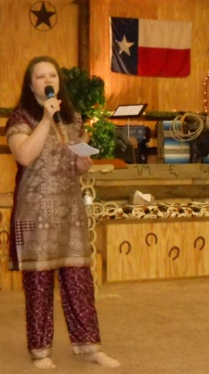
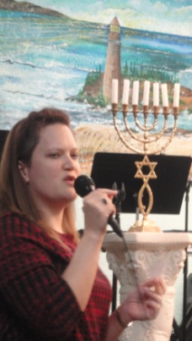
By Amy Anderson

I grew up in rural Maryland, USA and family gatherings included fun dancing to banjo and fiddle music. Raised Catholic and Methodist, I experienced a tangible touch of God during a confession time. But then at the passing of my mother, I started to experience panic attacks and my sister took me to a Pentecostal church where I truly dedicated my life to God and literally felt fear leave when my pastor said the name of ‘Jesus’ over me. Two years later, I read The Holy Spirit and You by Denis and Rita Bennett and spoke in a new heavenly language. I also attended services held by a traveling evangelist and got a taste of supernatural joy and things recorded in revival history like shaking. Wow…I felt a new level of freedom. A little while later I got ill with asthmatic bronchitis and unlike before I could not get better…even after many trips to the doctor. Finally, I ask my sister to lay hands on me and pray. “Father, heal my sister.” she said. I then felt heavy and laid down on my kitchen floor and started experiencing joy and laughter. I felt so much better, I went to church that night and when the music started I began to dance. At one point I jumped up for joy and suddenly (it felt like) I spun in mid-air. I screamed but then two words came to mind, “Trust Him.” I then thought this must be God finishing my healing so I just relaxed. My body fell to the floor and rolled all around the back of the church. “Holy rolling” is real…and somewhat fun. It seems to be part of deliverance. My sister, the band and the ushers watched as God displayed His power and the rolling turned into a detailed, choreographed and spontaneous dance to every beat of the music. I was a just as much an observer as they were. When the music stopped, I wept in awe. God not only healed me; He gave me another dance! I had always danced with my earthly family; but now I had learned how to dance with my heavenly family and for my Bridegroom, Jesus. Later in life, I would meet many people around the world that had also experienced this including one girl in Ukraine that had an almost mirror image of my experience. Why do I share my story and dance? I believe God will draw people closer to Himself as I share my experience. God is love. John 12:32
www.dancingdietitian.com
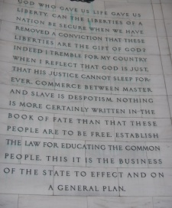
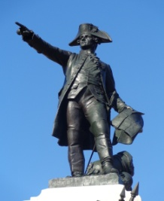
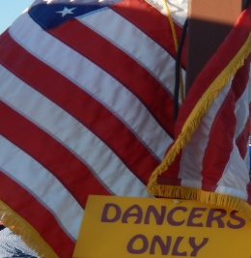
Second Samuel 6:14 states that "...David danced before the LORD with all his might" KJV More and more churches are open to dance ministry and now Christian Praise Clubs are popping up all over the world. Dance has a duel benefit...it can be used to worship God and it happens to be a great workout. Scripture indicates that God likes a new song sung to Him. I suspect He likes new dances too since He gave me one that has helped take me around the world. As I travel and share my healing testimony, I'm always surprised at the number of people who come up to me afterwards with tears in their eyes. Most want to dance for God!!! Many were touched spiritually, emotionally, and even physically while I danced. God is a limitless loving Father. Bottom line...WE CAN DANCE...for Him! Follow me at: www.facebook.com/dancingdietitian

