Testimony of the 1st time God spoke to me (2 yrs after I experienced salivation, a month after the Holy Spirit with evidence of speaking in tongues) I believe it is a word for the USA for 2014 and beyond.
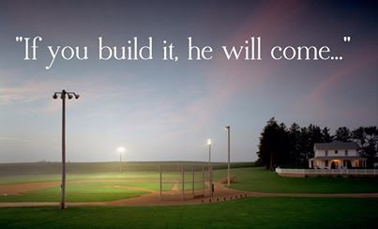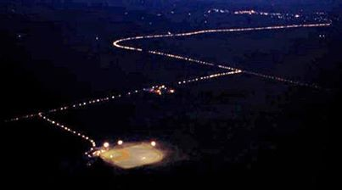

Oct 19, 1995 (6th Edition Manangement Textbook at West Virginia University pg.156)
IF YOU BUILD IT, THEY WILL COME

Oct 20, 1995 (last scene of Fields of Dreams movie - visiting my brother - I had sensation of my tongue)
There is a field of souls. Angels are working among these souls; but, they need your help. Do not give in to financial hardship. Child-like faith will see the vision. People will come from miles around! Some will not even know why. They will come for reasons they can’t even fathom. They will arrive at the borders as innocent children. Money will come from these people. Some will come for peace and in search of something they had in their past. I will reserve their seats for them on a perfect afternoon. They will praise Me. It will be as if they have dipped themselves in magical waters. The memories will be so thick that they will have to brush them away from their faces. People will come! They will come for the one Constant that has remained throughout the years…God. America has steam-rolled over the church. True Christianity has been built up and erased repeatedly. God has marked the time…this nation…cities of refuge. It will remind you of all that once was good…and it can be again. People will come! People will most definitely come! Do not listen to Satan or unbelievers. Satan will attack. Do not worry, the guardian angel will be available. Eyes will be opened through miracles. I make good come from bad. Thank you for what you are doing. Be careful not to do this for just your reward. Do it for Me and my people as well and take care of your families. There is a reason I chose you and there is a reason I chose this nation. Don’t let pride creep up. Revival will come to dead, dry America. It will be in the headlines. If you build My kingdom, I will come. I am your Father. Ease the pain I have for my people and go the distance. Thank you for building this nation and allowing my presence to come. I am the King and I love you. There is work to be done. It will be a joint effort. My dream is coming true. My kingdom is being revealed in my people. There is a heaven…it’s the place where dreams come true. I desire fellowship with you. You were made in my image. I AM THE LIGHT OF THE WORLD AND PEOPLE ARE COMING…MANY MORE THAN WHAT YOU CAN IMAGINE. Headlights will be lined up for miles. If you believe the impossible, the incredible can come true.

Oct 21, 1995 (in Cumberland Times News)
Build it…and the world will come. There will be power in the church and people will come from all over the world. Overcome. Which state will lead the nation? Have vision and confidence in Me. If you see the big picture, you will realize this kind of power is a new tool in your tool chest. Have open minds and commitment. Build it and the world will come. 