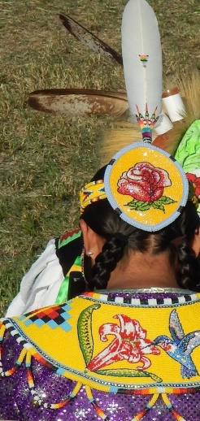
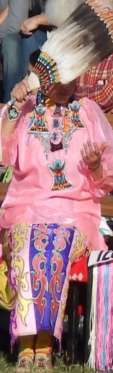
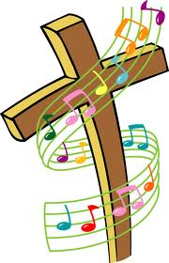
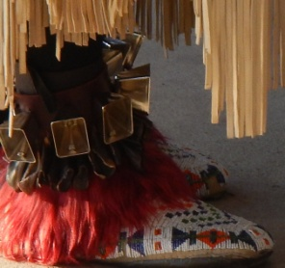
Mission Moves 2014 Psalm 149:3
By Amy Anderson
Dance is multi-cultural and attracts all ages. “Dance is a common element of every Native American culture. Archaeological finds confirm the importance of dance to all indigenous people throughout the world! This powerful expression was used as a way to celebrate victories and acts of bravery in battle.” Dancing is an uplifting experience of self-transformation, creativity, spontaneity and revitalization. For centuries, desert people practiced their only sure way to break a drought. They prayed. They danced. People were used as representatives of clouds and united as one (dancingtoeaglespiritsociety.org). In the same way, the Book of Revelation 1:7-8 states, “Look, he is coming with the clouds, and every eye will see him, even those who pierced him; and all the peoples of the earth will mourn because of him. So shall it be! Amen.” Clouds are the saints manifesting His glory as a corporate expression of the appearing of Christ. Clouds are those people IN WHOM He is coming. This is concerning His ‘appearing’ within a cloud of witnesses. You and I are to become the clouds of His appearing. In Rev 10:1 the clouds are His clothing! Similarly, a sermon by the late M.B. Etter states, “...dancing under the power of the [Holy] Spirit is altogether different. It is spontaneous. It comes [many times] without premeditation or choice. It lacks all human direction and control. It does not follow…[a] dance ever learned. The steps are controlled and directed by the Holy Spirit. The whole body is energized by the Spirit. The eyes are [sometimes] closed. The movements are [usually] wonderfully graceful and often rapid beyond all possibility of imitation. [Rarely]… are…[there] attitudes or poses or familiar joining of partners, which characterize…ordinary dance.” (Dancing in the Spirit Always Means Victory) PLANET DANCE DANCE IS A WEAPON
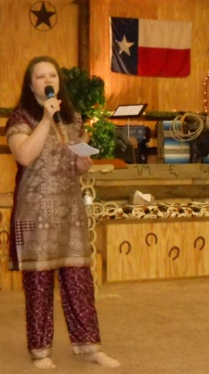
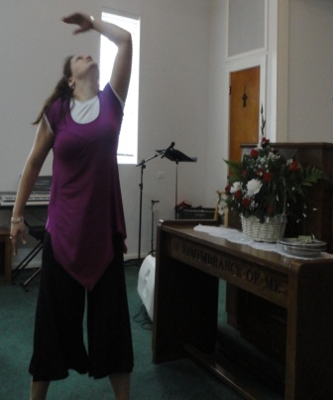
My testimony: I grew up in rural Maryland, USA and family gatherings included fun dancing to banjo and fiddle music. Raised Catholic and Methodist, I experienced a tangible touch of God during a confession time. But then at the passing of my mother, I started to experience panic attacks and my sister took me to a Pentecostal church where I truly dedicated my life to God and literally felt fear leave when my pastor said the name of ‘Jesus’ over me. Two years later, I read The Holy Spirit and You by Denis and Rita Bennett and spoke in a new heavenly language. I also attended services held by a traveling revivalist and got a taste of supernatural joy and things recorded in revival history like shaking. Wow…I felt a new level of freedom. A little while later I got ill with asthmatic bronchitis and unlike before I could not get better…even after many trips to the doctor. Finally, I ask my sister to lay hands on me and pray. “Father, heal my sister” she said. I then felt heavy and laid down on my kitchen floor and started experiencing joy and laughter. I felt so much better, I went to church that night and when the music started I began to dance. At one point I jumped up for joy and suddenly (it felt like) I spun in mid-air. I screamed but then two words came to mind, “Trust Him.” I then thought this must be God finishing my healing so I just relaxed. My body fell to the floor and rolled all around the back of the church. “Holy rolling” is real…and somewhat fun. It seems to be part of deliverance. My sister, the band and the ushers watched as God displayed His power and the rolling turned into a detailed, choreographed and spontaneous dance to every beat of the music. I was just as much an observer as they were. When the music stopped, I wept in awe. God not only healed me; He gave me another dance! I had always danced with my earthly family; but now I had learned how to dance with my heavenly family and for my Bridegroom, Jesus. Later in life, I would meet many people around the world that had also experienced this including one girl in Ukraine that had an almost mirror image of my experience. Why do I share my story and dance? I believe God will draw people closer to Himself as I share my experience (John 12:32). God is love and He has taken me to Mexico, Canada, India, China, Germany, Czech Rep, Romania, Bulgaria, Turkey, Switzerland, and Ukraine. Second Samuel 6:14 states that "...David danced before the LORD with all his might." KJV

Bottom line...WE CAN DANCE...for Him! Follow me at: facebook.com/dancingdietitian or visit dancingdietitian.com
Christian American Indian resource: wfconline.org

